OKLAHOMA BUSINESS ETHICS CONSORTIUM
Oklahoma City Chapter ~ March 12, 2008
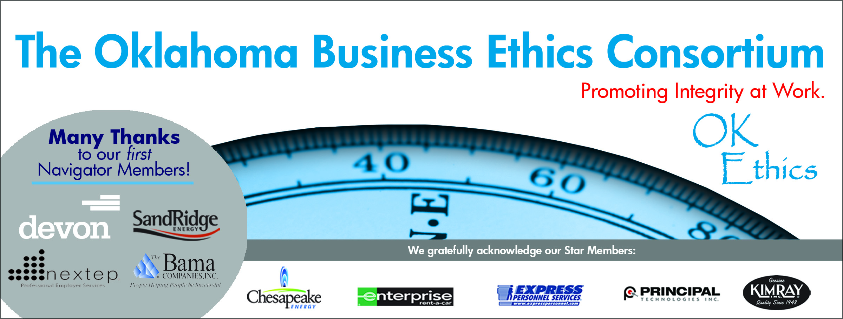
VISION: To be recognized as a statewide (and national)
forum for promoting business ethics.

- KUDOS & WELCOME Shannon Hiebert; Vice President of Human Resources,
Enterprise Rent-A-Car
President & Founding Member of OkEthics Consortium
Guiding Principle: HONOR
We express gratefulness to our hosts, sponsors and speakers.
Everybody can be great... because anybody can serve. You don't have to have a college degree to serve. You don't have to make your subject and verb agree to serve. You only need a heart full of grace. A soul generated by love.
– Martin Luther King, Jr.
  - Greg Byers of Sinclair Broadcasting Group – Every month, Greg is in charge of making sure that the registration process goes smoothly. We depend on Greg’s conscientious attention to detail and sense of hospitality in making our guests feel welcome every month.
  - Mary Kay Huggard & the Principal Technologies team for their reliability in making themselves available to help our guests and members with registrations. We appreciate their generosity of time.
  - Joshua Jantz of IBLP for preparing and organizing our name tags every month.
  - Connie Barwick – Maximum Multi Media Creations for the pre-meeting Power Point presentations, bookkeeping and website expertise.
  - Jana Boren of Devon for making arrangements for former governor George Nigh to be our Compass Awards keynote speaker on April 28.
  - Linda Manaugh of Metro Tech and Shannon Hiebert for the handouts on Compass Awards & agendas.
  - Digital West’s Blaine Rider & Ted West for filming this event – DVD’s will be available by contacting Shannon Warren at warrenokla@cox.net Cost is $10 per DVD.
  - Colin Autin & Edith Steele of the Oklahoma Accountancy Board for providing the CPE certificates. (Available at the registration desk at the conclusion of this program.)
  - Fred Imel, CPA, Phil Busey of The Busey Group and Dr. Earlene Smith of Rose State College for setting the example of sharing our organization and recruiting others to participate.
  - Welcoming Jared Cawley of The Busey Group to the OkEthics Board of Directors as Associate General Counsel.
  - Dr. Katherene Terrell of UCO for spearheading the statewide OkEthics challenge event on the UCO campus.
  - Behind the scenes, our dedicated volunteers who serve on the Board and are the heart of this organization!

Please help promote Oklahoma values of integrity at work:
Join OkEthics by going online to www.okethics.org

- COMPASS AWARDS Garyl Geist, CEO of Valir Health,
2006 OkEthics Compass Award recipient & OkEthics Horizon member
  - Application Deadline is March 28 ~ Start Early!
  - See last year’s recipients and finalists at www.okethics.org for shared practices
  - April 28 is annual Compass Awards Banquet featuring keynote speaker former Oklahoma governor, George Nigh

III. TABLE-TOP DISCUSSION John Burnett, Character First Institute
“Tolerance, Respect and Honor”

IV. INTRODUCTION OF GUEST SPEAKERS Shannon Warren, Founder & Volunteer, OkEthics

MANY THANKS TO OKLAHOMA CITY UNIVERSITY – PARTNERS IN TODAY’S PROGRAM

Special Note: As Dean of the Meinders School of Business for Oklahoma City University, Dr. Vince Orza has been very gracious in the awarding of two $5000 scholarships again this year. We appreciate the generosity of OCU as they continue to provide inspiration to the youth in our community. This year, the scholarship awards will honor Bob Mills and OkEthics member Phil Busey of The Busey Group. Members are asked to encourage students to apply online at www.okethics.org

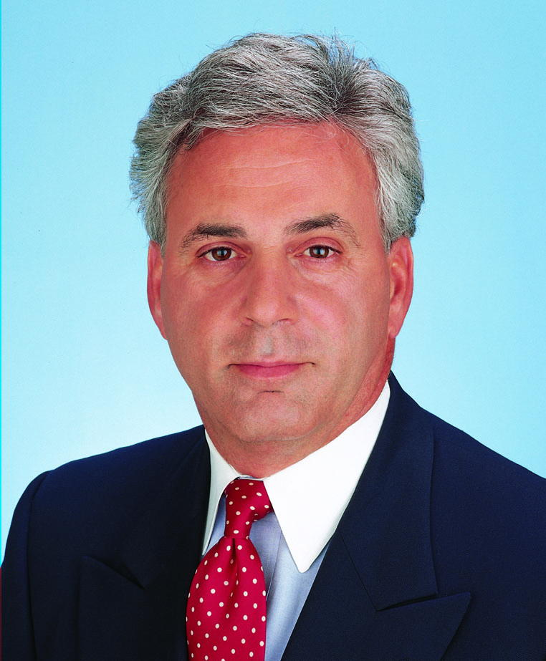 | 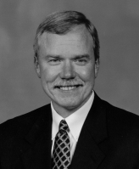 | 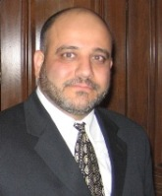 | 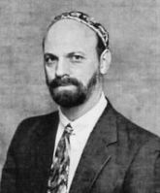
Dr. Vince Orza  Dean  Meinders School  of Business  Oklahoma City University | Dr. Bob Long  Senior Pastor  St. Luke's  United Methodist Church | Dr. Imad Enchassi  Imam  Islamic Society  of  Greater  Oklahoma City | Rabbi  Russell Fox  Emanuel  Synagogue
Please see attached outlines of presentations from Dr. Long and Rabbi Fox.
Also, as a convenience, the Islamic Society has provided booklets at each table.
V. UPCOMING EVENTS Shannon Warren, OkEthics’ Founder
Advance reservations required for all events ~
Visit our website at www.okethics.org or call 858-2233;
Member discounts apply regardless of location.
Norman Chapter – Please join us for the statewide awards (see below)

OKC Chapter
- April 28, 2008 – STATEWIDE ANNUAL COMPASS AWARDS
Honoring companies for openly sharing their best practices in business ethics.

- May 14, 2008 – Attorney General Panel
  - Larry Derryberry
  - Mike Turpen
  - Susan Loving
Special thanks to Tony Blasier of Chesapeake Energy for organizing this milestone event!

Tulsa Chapter
- March 27, 2008 – Rick Brinkley, CEO of Better Business Bureau of Tulsa presents:
“Recognizing and Avoiding Business Scams”

VI. OTHER RELATED PROGRAMS:

Character First Institute - March 27 – “Persuasiveness”

Oklahoma City Business and Community Leaders' Luncheon

Registration Information: Call 815-0001, or visit www.characterok.org

OkEthics is very grateful for the support of over 600 individual members statewide:

For a complete listing of sponsors, please visit our website at www.okethics.org
See also additional sponsors listed on our website.

NAVIGATOR MEMBERS – $7500 level
- BAMA COMPANIES (Tulsa)
- DEVON Energy
- NEXTEP (Norman)
- SANDRIDGE ENERGY
Many thanks to our Navigator sponsors for their continued support! Shows support at highest level of commitment in terms of funding ($7500) and participation.

OKLAHOMA STAR MEMBERS
-- $5000 level
- Chesapeake Energy
- Express Personnel Services
- Enterprise Rent-A-Car
- Kimray, Inc.
- Principal Technologies
The Oklahoma Star membership of $5000 Includes 8 memberships; prepaid for all OkEthics events. Shows support by allowing OkEthics to post logo on Home page of website and promotional materials.

HORIZON MEMBERS – $2500 level
Dollar Thrifty Automotive Group (Tulsa); Helmerich & Payne (Tulsa); Norris (Tulsa);
The Rowland Group (Tulsa); Metro Technology Centers (OKC); SemGroup (Tulsa);
Valir Health (OKC)
PLEASE HELP US CONTROL COSTS BY LEAVING YOUR NAME TAG HERE!
Oklahoma Business Ethics Consortium
Guiding Principles
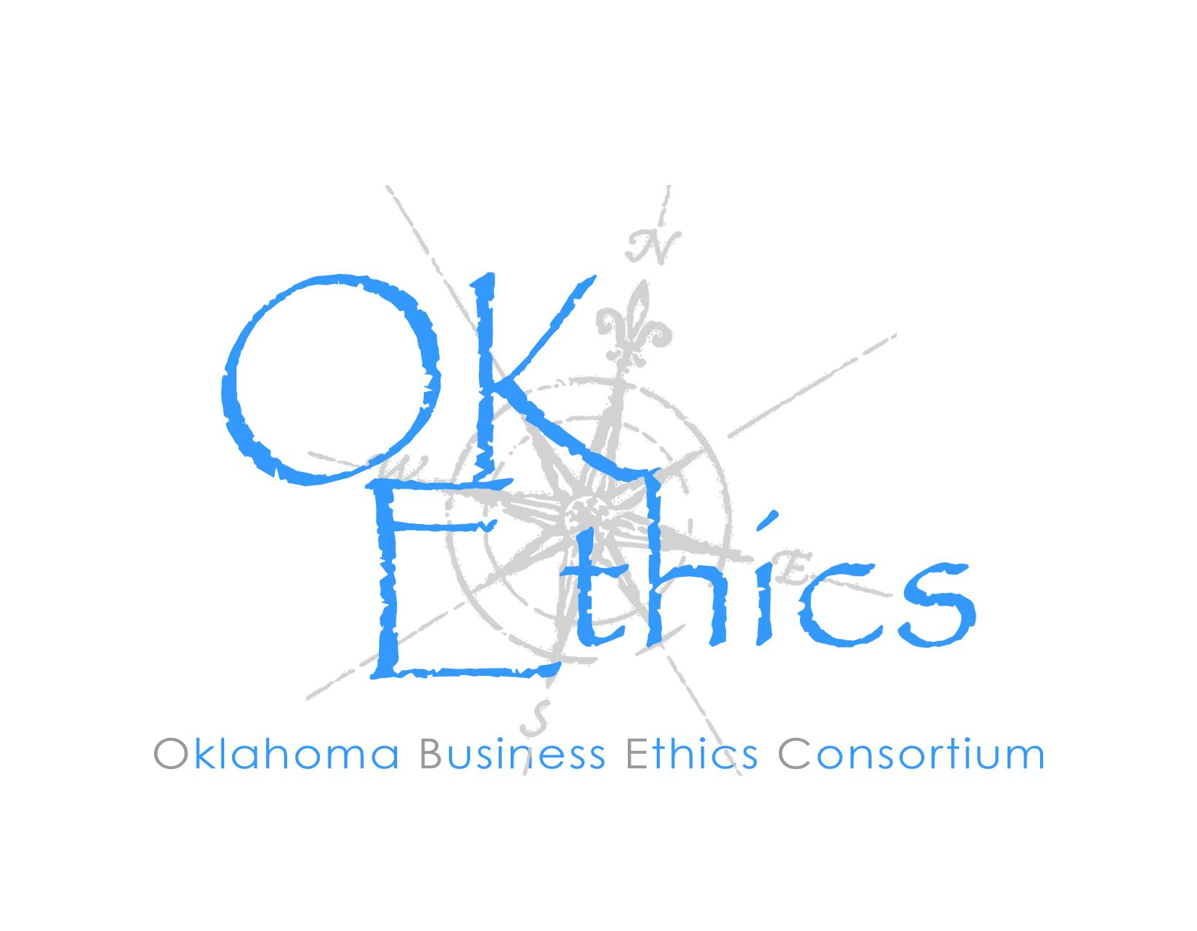
To ensure that the Consortium fosters positive characteristics of integrity in the successful achievement of its goals, these Guiding Principles were adopted by OkEthics in 2004. We deeply appreciate the guidance offered by the Character First Institute in openly sharing their values and philosophies in the development of these Principles..

I. Responsibility to Self and Others:
- Service:
  - Passion for promoting ethics and integrity
  - Encouraging the promotion of ethical behavior through personal actions and
  - Sharing ideas and resources
  - Responsibility and accountability for fulfilling the mission of the Consortium.

- Collaboration:
  - Achievement of common goals through mutually beneficial relationships
    - Service to the Consortium over promotion of self-interest
    - Cooperation over competition in the context of the Consortium’s efforts
Members collaborate by being Constructively engaged in discussion and topics
    - Seeking consensus in interactive discussions

- Respect:
  - Members may become aware of confidential information shared by others in an effort to determine an ethical course of action. We ask members to be sensitive in recognizing and respecting the efforts made toward achieving ethical behavior. In that vein, public disclosure of this information is discouraged.
  - We respect other members and the process by:
    - Exhibiting listening skills and actively listening to discussions
    - Being open to other points of view and outcomes
    - We are an inclusive organization and demonstrate this by welcoming members who are in different stages of learning as applied to ethical behavior.

II. Lead with Integrity

- Dependability:
  - Members are asked to demonstrate their support of this initiative by consistently attending meetings.

- Initiative:
  - Recruiting other members who have demonstrated a desire to promote ethical behavior in their organizations.
  - Recognizing what needs to be done to help promote the Mission of the Consortium and taking action to assist in that effort.

- Honor:
  - Members are asked to honor the Consortium through the practice of integrity and ethical behavior in their business dealings.
  - We express gratefulness to our hosts, sponsors and speakers.
  - Realizing that each of us is in a mode of continual learning, we demonstrate humility, care and compassion when sharing our thoughts and knowledge.

- Courage:
  - Speak the truth with confidence and encourage others to do the same.

Religion’s Impact on Ethical Decision Making in Business
Dr. Robert E. Long
Sr. Pastor, St. Luke’s United Methodist Church

I. Does anybody remember the Golden Rule?

II. Is it possible to practice the Golden Rule in business?
- We live in a culture of competition
- We celebrating winning – whatever the cost
- Being #1 not #2 is what matters
  - Culture of Competition Where Winning is All that Matters – We Can Justify Tearing Other People Down
- Can you be successful if you practice the Golden Rule?

III. The Golden Rule is a Foundational Value for All Great Religions
  - Confucius
  - Hillel
  - Jesus
  - Mohammad

IV. Can a Person Really Lead by Asking the Question, “How would I want to be treated?”

V. Culture is How People Act Without Rules
- We seek to legislate conduct.
  - Sarbanes Oxley
  - Policy handbooks
    - Rather than seeking to legislate conduct, can we buy into common values?
    - What are the values that are most important to your organization?
    - How are they reinforced? Do they align with principle of Golden Rule?

General Disclaimer: Members of the Oklahoma Business Ethics Consortium frequently share information concerning various issues and developments that may have legal implications. The discussions, commentary, and handouts at Consortium meetings or presentations to other organizations are for general informational purposes only. They cover only some aspects of the subject topic, and do not constitute a complete legal analysis of the topic or how it might apply to any particular set of facts. Before taking any action based on information presented during a Consortium event, participants are encouraged to consult a qualified attorney. The observations and comments of presenters at Consortium meetings and networking are the views and opinions of the presenter and do not constitute the opinion or policies of the Consortium or any of its members. Presenters are respectfully requested to avoid profanity, preaching, politics and self-promotion during their lectures. It is the responsibility of participants to demonstrate applicability of each program for demonstration of earned CPE credits.

Religion’s Impact on Ethical Decision Making in Business

Rabbi Russell Fox
Emanuel Synagogue

Judaism and the Ethics of the Workplace – Ten Talking Points

- No Separation of Sacred and Commonplace. In the Bible, laws governing social conduct are interspersed with ritual commandments.

- Biblical Society Based on Equality. The Bible and later rabbinic law assume all persons are equal before the law. Tendencies to advantage the powerful are counteracted.

- Stewardship, Not Possession. Wealth, capital, and ownership bring with them the responsibility to administer resources for the greatest good of the community.

- Justice, Not Charity. The Jewish principle of tzedaka means giving to those less fortunate because it is the right thing to do, rather than because our compassion has been stirred.

- Mutual Responsibility, Not Winner Take All. Commerce is about making a living and improving the world, not maximizing profits.

- Honor Is Life. The marketplace and workplace should be places where no one is shamed.

- Ethical Behavior As An Ideal. We should always strive to go beyond the letter of the law and improve our ethical standards. Ethics is not static.

- When No One Is Watching. The ultimate test of our ethics is hat we choose even when there is no oversight or fear of consequences.

- Good Manners Are Ethical. While politeness and decency may seem unrelated to ethical behavior, their cultivation develops in us the same attentiveness needed for good moral judgment.

- The Golden Rule, What is hateful to you, do not do to another.

